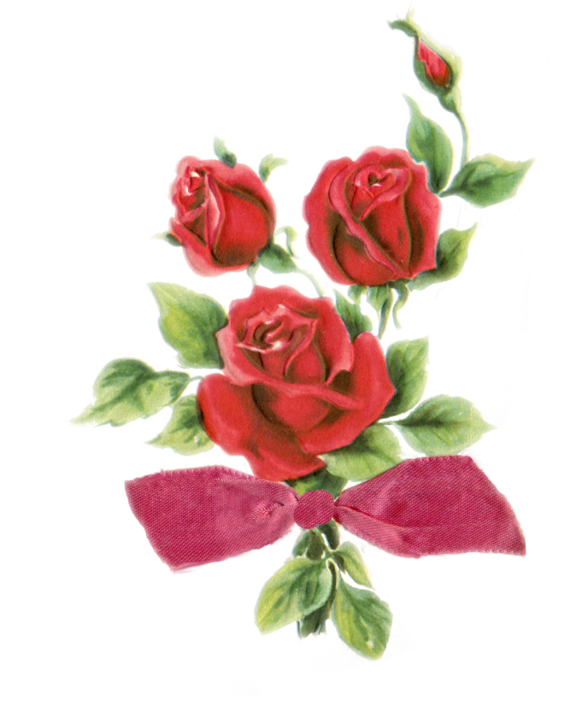
THREE EVERLASTING RED VELVET ROSES $7.00
YOU MAY BRING FLOWERS FOR YOUR DANCER, OR YOU MAY CHOOSE TO PRE-ORDER AN *EVERLASTING PRESENTATION BOUQUET FOR YOUR DANCER. PRE-ORDERED SOUVENIR FLOWERS WILL BE AVAILABLE FOR PICK-UP IN THE THEATER LOBBY DURING INTERMISSION. Flowers can be presented to dancers after the finale.
PROCEEDS FROM YOUR ORDER HELP SUPPORT THE ELITE COMPETITION TEAM.

DANCER’S NAME___________________________________________

ORDERED BY______________________________________________

QUANTITY_______________ X $7.00 = PAID $____________________
_______ CASH
_______CHECK
*NOT FRESH FLOWERS

